MAX-WIDTH

1. MAX-WIDTH

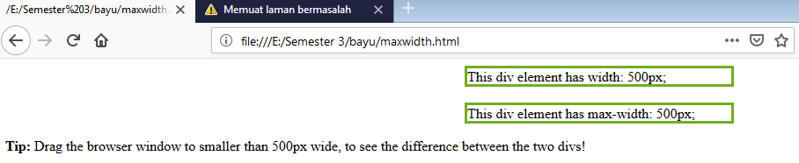

Keterangan:

<title>css max-width</title> : max-width(ID lebar maximal) ini hampir sama dengan property width, bedanya fungsi dari max-width hanya mengatur lebar maximal saja.

**SOURCE CODE**

<html>

<head>

<style>

div.ex1 {

width:300px;

margin: auto;

border: 3px solid #73AD21;

}

div.ex2 {

max-width:300px;

margin: auto;

border: 3px solid #73AD21;

}

</style>

</head>

<body>

<div class="ex1">This div element has width: 300px;</div>

<br>

<div class="ex2">This div element has max-width: 300px;</div>

<p><strong>Tip:</strong> Drag the browser window to smaller than 500px wide, to see the difference between

the two divs!</p>

</body>

</html>